A Free Operating System For A Free Community

What Is Fedora?
Fedora is an operating system and a development platform based on Linux that is free to use, free to modify, free and legal to redistribute, and free from potentially damaging software patent encumbrances.
Fedora is built from the latest technologies from the free software world, and developed by a community of users and developers who are passionate about providing and maintaining the best free software distribution in the world.

What Is the Fedora Project?
The Fedora Project is a Red Hat sponsored and community supported open source project. Our goal is the rapid progress of free and open source software and content. The Fedora Project makes use of public forums, open processes, rapid innovation, meritocracy, and transparency in pursuit of the best operating system and platform that free software can provide.

Fedora Project
http://fedoraproject.org

Fedora Ambassadors



http://fedoraproject.org

Fedora is a registered trademark of Red Hat Inc

Fedora
Fedora comes on a installable DVD or in a 5 CD set. Packages are selected to cater to a broad spectrum of use, from home and business use, to system administration and software development. No matter who you are, Fedora can provide you with the best free software to meet your needs.
The Desktop
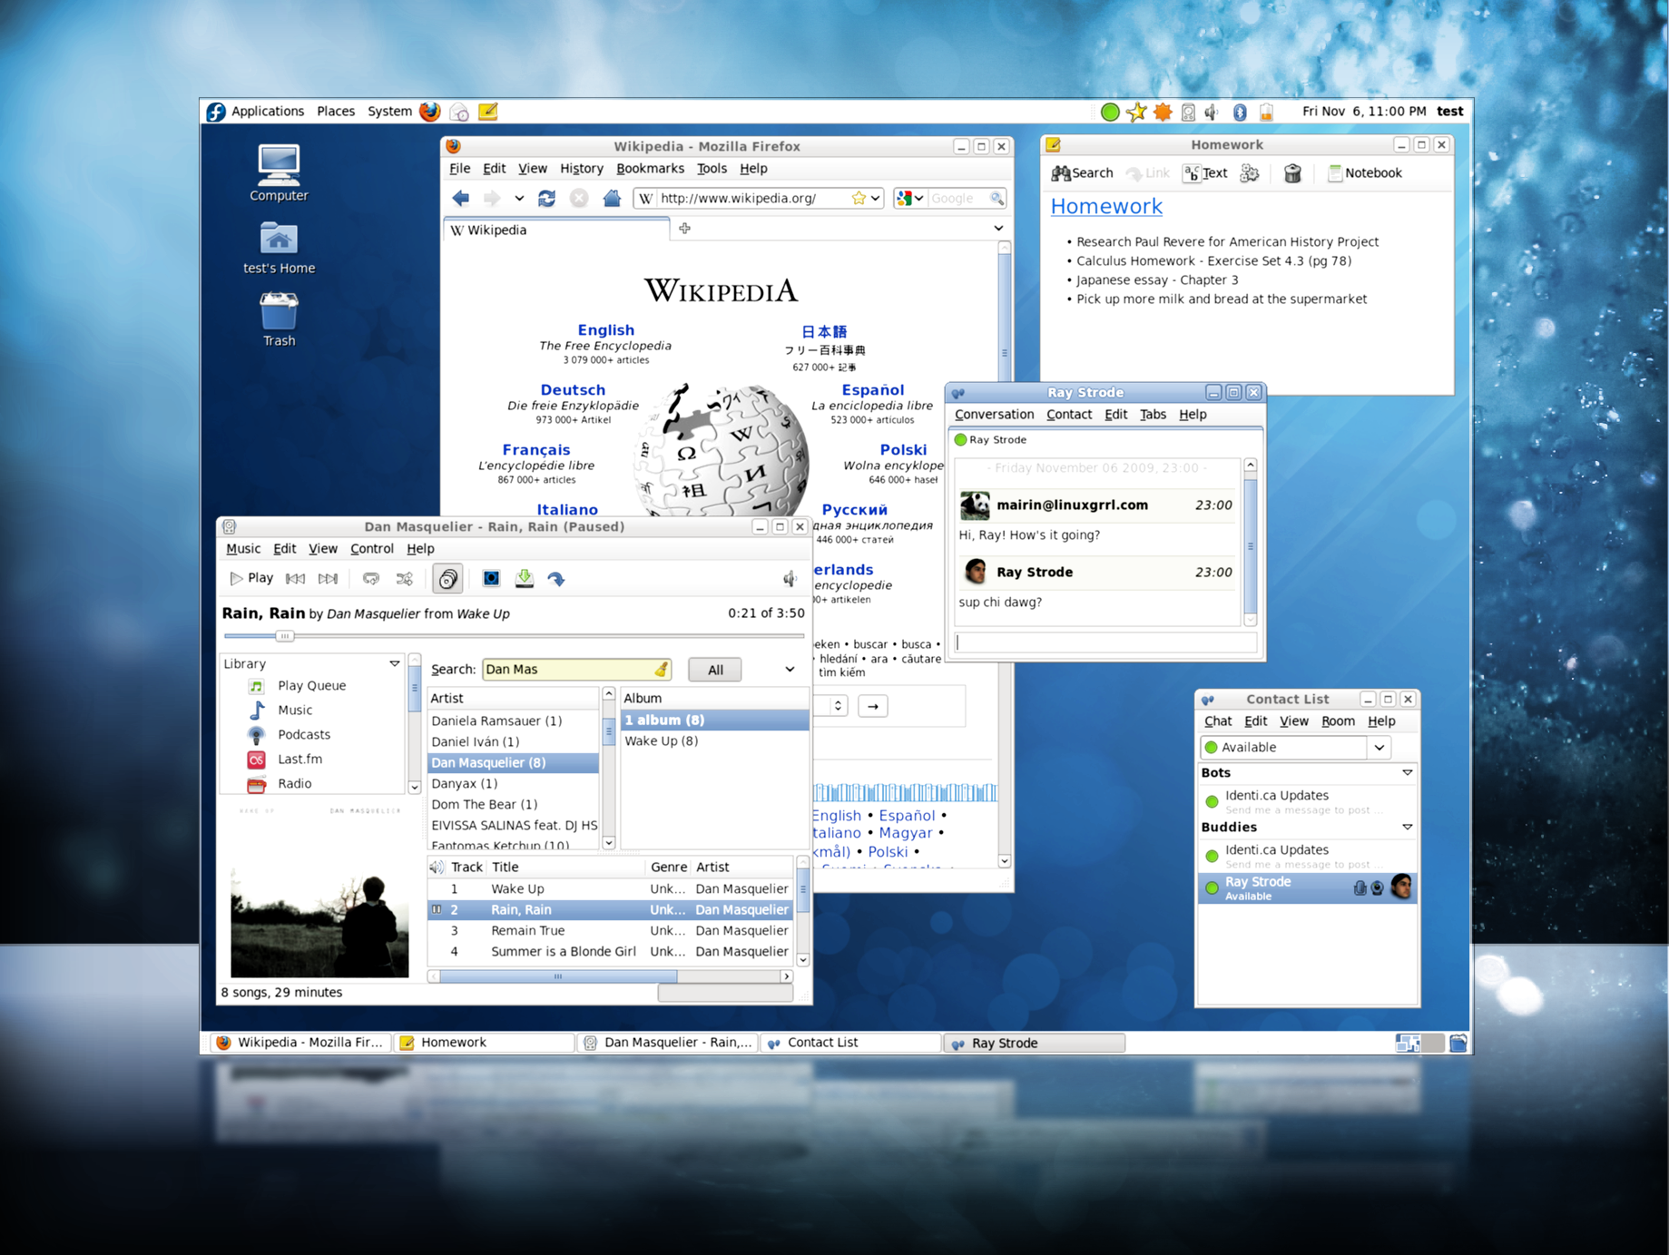
The default Fedora desktop uses the GNOME desktop environment. It is easy to use, simple and suitable for everybody. You are free to change the themes, or even to replace it with a different desktop environment altogether.
For the eye-candy lovers, Fedora includes Compiz Fusion, a 3D desktop, in its default installation.
If GNOME is not your desktop of choice, KDE and XFCE are readily available.
OpenOffice
OpenOffice.org is a multi-platform and multilingual open source office suite. It has everything you need for productivity in your business, studies and everyday tasks.

- OpenOffice Writer
(Word processor)

- OpenOffice Calc
(Spreadsheet application)

- OpenOffice Impress
(Slide show designer)
Network Manager
NetworkManager provides improved wireless network management and sharing support. It includes support for multiple devices and provides the capability of system-wide configuration, among many other enhancements to make your networking experience easier.
Pulse Audio
Pulse Audio is installed and enabled by default. Pulse Audio is an advanced sound server compatible with nearly all existing Linux sound systems. Pulse Audio allows for hot-switching audio outputs, individual volume controls for each audio stream, networked audio, and more.
Plymouth
With Plymouth, the new graphical boot sequence, the startup experience became flicker-free, seamless, shiny and faster!
Getting Fedora
Fedora can be acquired easily through public mirrors, BitTorrent or using Jigdo.

http://fedoraproject.org/get-fedora

Getting Support
- Official Documentation
http://docs.fedoraproject.org/
- Mailing List
https://admin.fedoraproject.org/mailman/listinfo/users
- IRC channel
#fedora @ irc.freenode.net
- Community forums
http://fedoraforum.org

Contributing to Fedora
Are you interested in contributing to Fedora? There are many ways you can become active in the project.
Whether you are a People Person, Designer, OS Developer, Packager or Administrator – we have a place for you. Just head to the following page and get started today!

http://fedoraproject.org/wiki/Join

